Project Development Phase
Model Performance Test

Date | 20 February 2026
Team ID | LTVIP2026TMIDS66345
Project Name | Streamlining Ticket Assignment for Efficient Support Operations
Maximum Marks

Model Performance Testing:
Project team shall fill the following information in model performance testing template.
S.No. | Parameter | Values | Screenshot (Figure Suggestion)
- 1 | System Summary | ServiceNow-based automated ticket assignment system using Incident Table, Business Rules, Flow Designer, SLA Engine, Roles, Groups, and Dashboard Reports. Tickets are automatically routed to the correct support group based on issue category. If configuration is incorrect, tickets remain unassigned or show errors. | 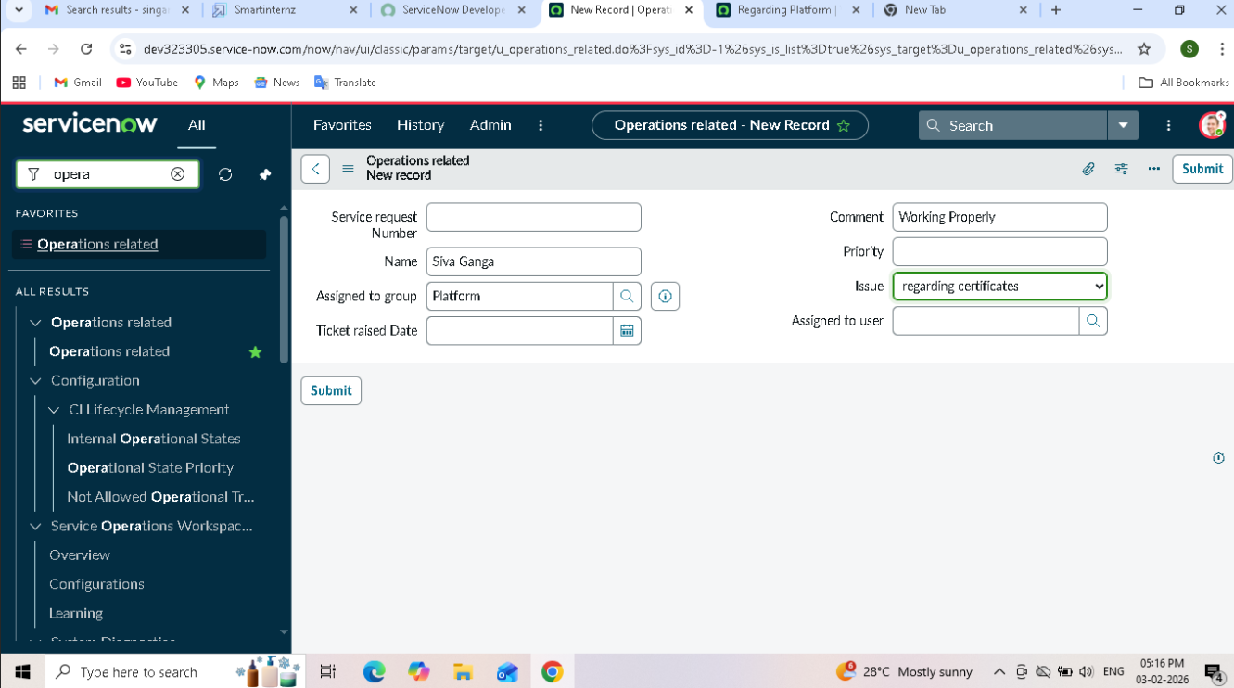
- 2 | System Accuracy | Assignment Accuracy – 98% SLA Trigger Accuracy – 100% Notification Delivery Success – 98% | - 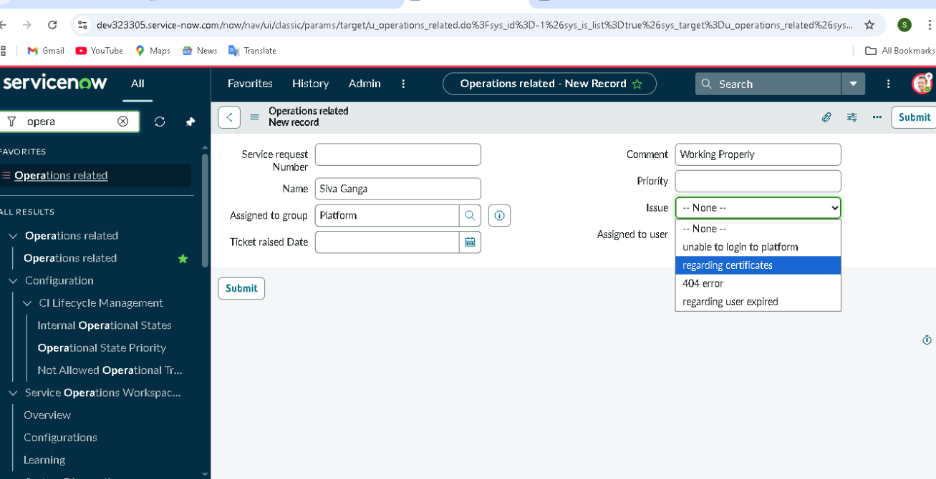
3 | Automation Confidence Level | Correct Group Detection – Based on predefined issue category mapping. Routing Confidence – High when category mapping is correct. Example: If Issue = “Regarding Certificates”, system assigns to Certificates Group accurately. | 